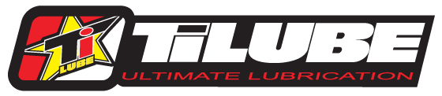
204 S Fillmore Street / Mount Ayr, IA 50854 / Ph. 641.464.3195

AMA Arenacross TiLUBE Contingency Registration Form

Rider Name ______________________________________________________
Address____________________________ City _______________ State ____ Zip ___________
Phone _(______)_____________
Email ____________________________________________

Classes ______________________ Bike Number _________
Year ______________ Make _____________________ Model ___________________
Dealer ________________________________________

